5. Views , sequence, synonmys

VIEWS

create view view_students as select stu_id,student_name,dept_id,age from students;

select * from view_students;

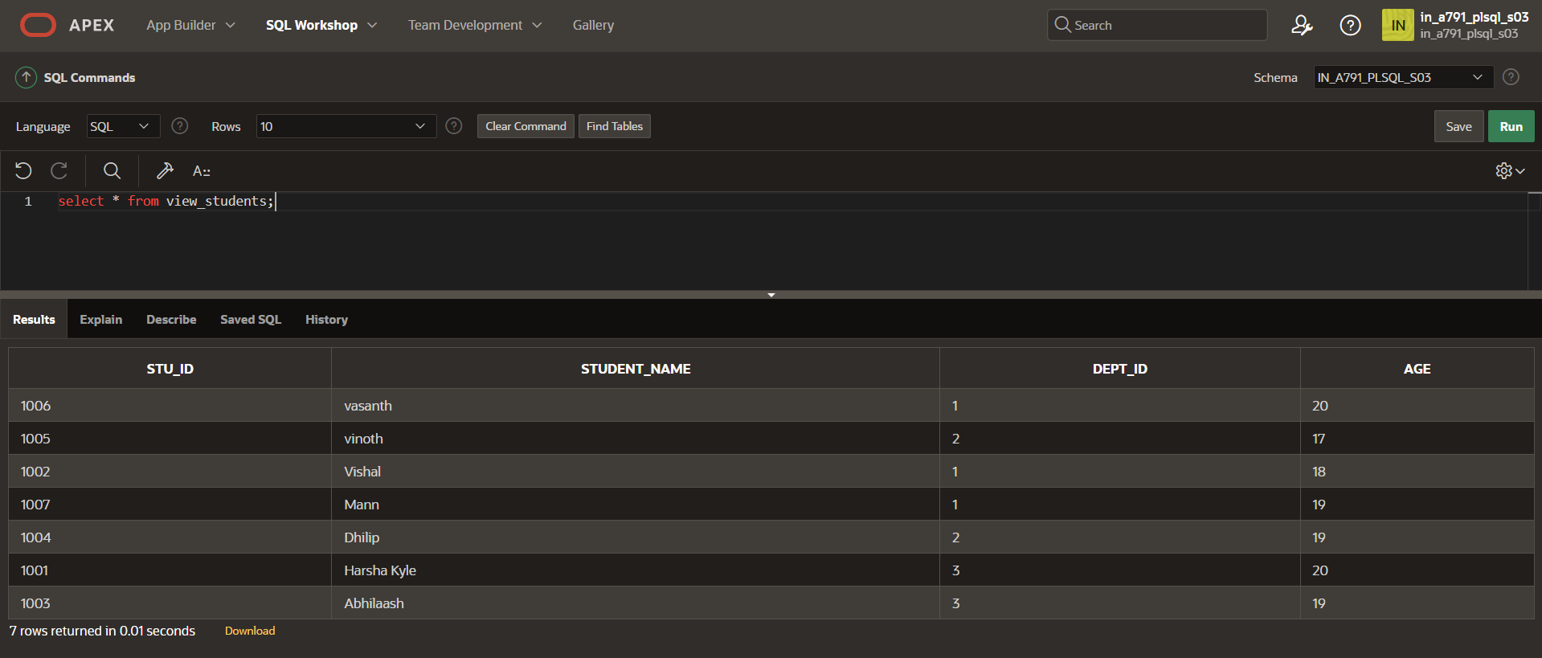

select * from view_students order by student_name;

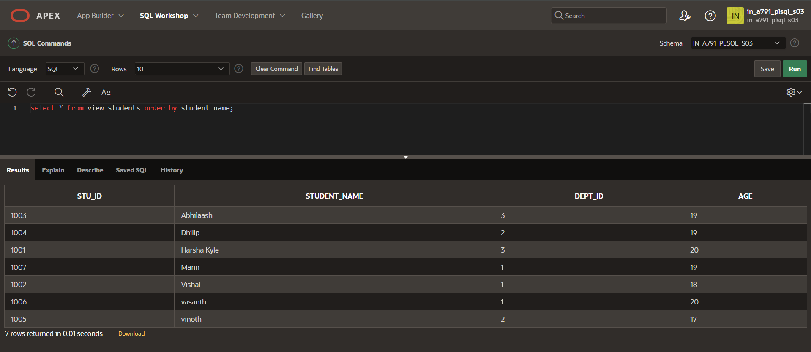

SEQUENCE

CREATE SEQUENCE sequence_1

start with 1

increment by 1

minvalue 0

maxvalue 100

cycle;

CREATE TABLE students1

(

ID number(10),

NAME char(20)

);

INSERT into students1 VALUES(sequence_1.nextval,'Harsha');

INSERT into students1 VALUES(sequence_1.nextval,'Vishal');

INSERT into students1 VALUES(sequence_1.nextval,'Abhilaash');

Select * from students1;

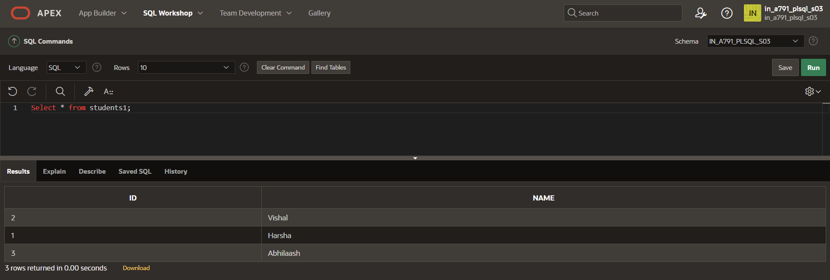

CREATE SEQUENCE sequence_2

start with 100

increment by -1

minvalue 1

maxvalue 100

cycle;

DROP SEQUENCE sequence_2;

SELECT sequence_1.NEXTVAL FROM students1;

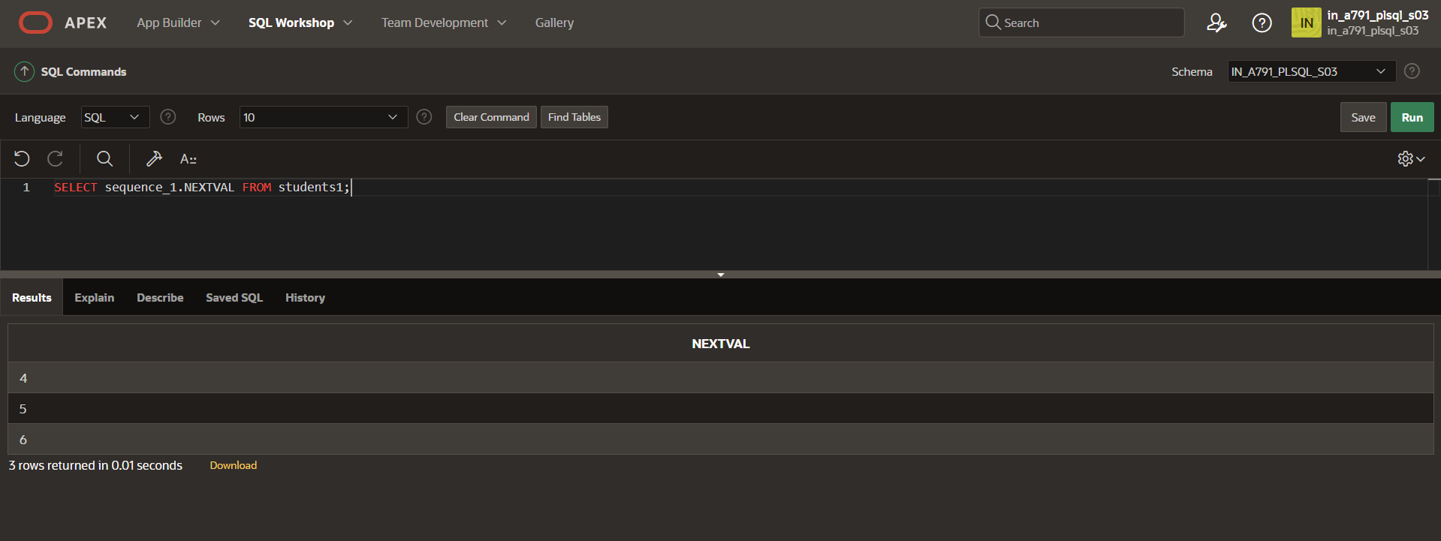

SYNONMYS

select*from students ORDER BY STU_ID;

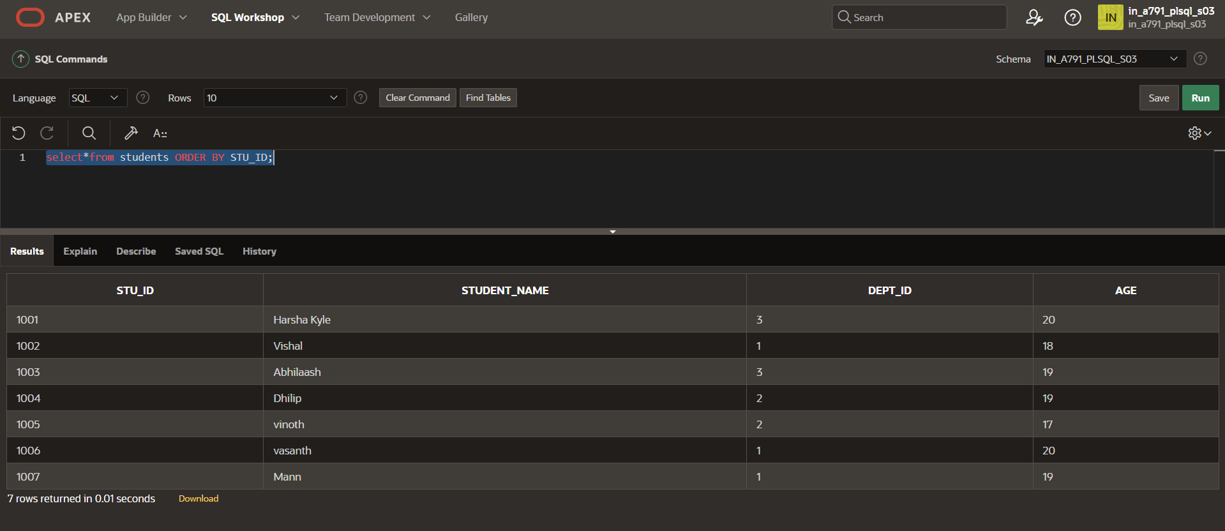

CREATE SYNONYM ST_DE FOR students;

select*from ST_DE;

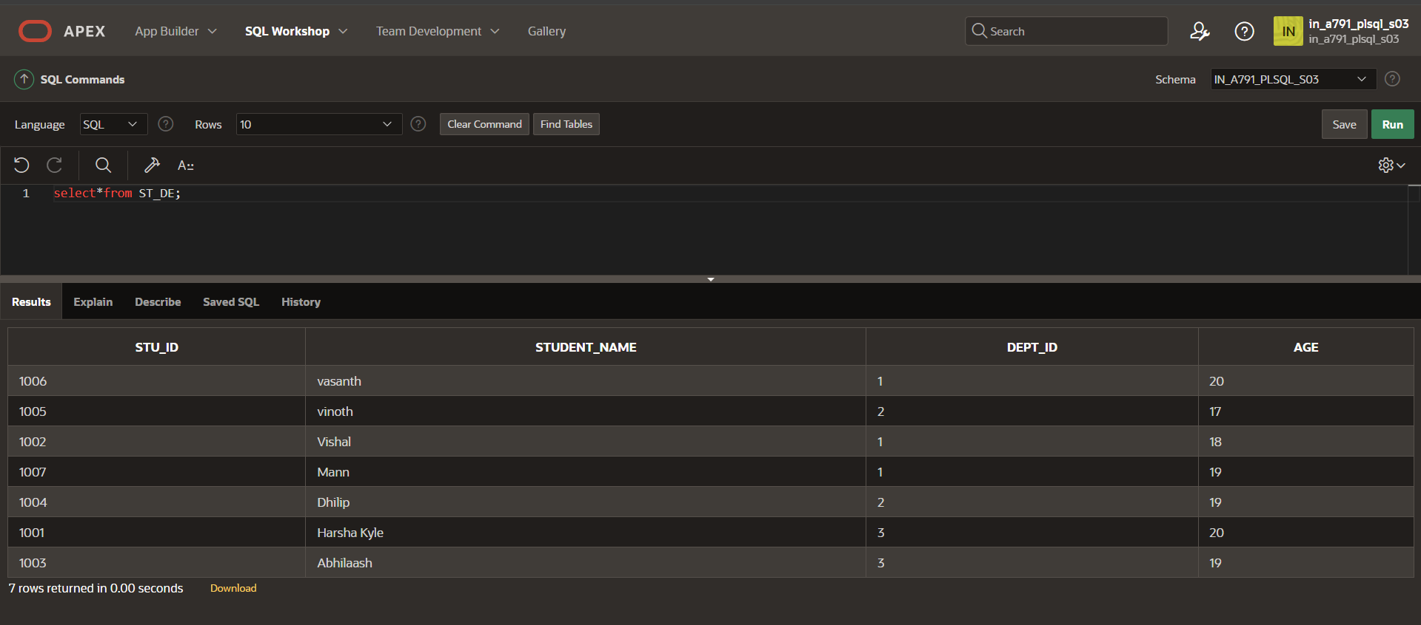

DROP SYNONYM ST_DE;